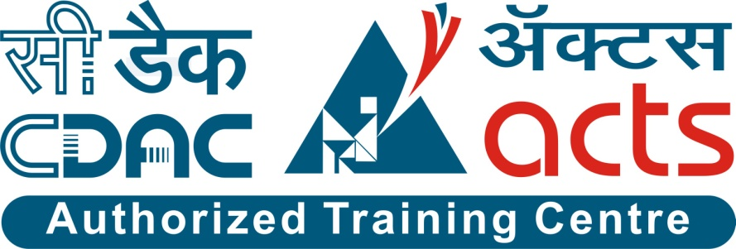

Project Name: Compare Vehicle Insurance

Branch PG-DAC Mar-2023

Documentation On

**“**Compare Vehicle Insurance**”**

PG-DAC March 2023

**Guided By: Dipali Jadhav**

Submitted By:

**Group No: 19**

* **Chetan Bawane 230343020011**
* **Pavan Gite 230343020034**
* **Vaibhav Jadhav 230343020038**
* **Ganesh Savant 230343020083**

**Table of Contents**

**1. Introduction 4**

1.1 Document Purpose **4**

1.2 Project Background **4**

1.3 Aim & Objectives **4**

**2. Business Requirements Overview**…………………………………………………………**5**

**3.Functional Requirements** **6**

3.1 Customer Module **6**

3.2 Policy Company Module **6**

3.3 Admin Module **6**

**4.** **Non-Functional Requirement………………………………………………………………7**

**5. Use Case Diagram 8**

5.1 Admin **8**

5.2 Customer **9**

5.3 Policy Provider Company **10**

**6. Database Design 11**

1 Login **11**

2 Vehicle Info **11**

3 Customer……………………………………………………………………………… **11**

4 Company **12**

5 Policy Plan **12**

6 Policy Details **12**

7 Payment **13**

**7. E-R Diagram………………………………………………………………………………………14**

**8. Architecture Diagram……………………………………………………………………………..15**

**9. Snapshots 16**

**10. Conclusion 24**

**List of Figures**

**Use Case Diagrams 17**

Fig 1 Admin 8

Fig 2 Customer 9

Fig 3 Policy Provider Company 10

Fig 4 ER Diagram 14

1. **Introduction:**
   1. **Document Purpose:**

The purpose of the online vehicle insurance project document is to provide a detailed overview of the project, including its objectives, scope, and timeline. The document will also outline the project's methodology, risks, and deliverable.

The document is intended for a variety of stakeholders, including project managers, developers, insurance companies, and customers. It will be used to communicate the project's goals and objectives, to track progress, and to identify and mitigate risks.

## Project Background:

The traditional process of comparing vehicle insurance policies involves contacting multiple insurance companies, manually gathering quotes, and trying to understand complex policy terms. This process is time-consuming and often leads to confusion among customers. There's a need for a centralized platform that allows users to easily compare different insurance plans, understand their features, and make informed decisions based on their preferences and needs.

## Aim & Objectives:

The online vehicle insurance project is a response to this growing trend. The project aims to develop a website that allows customers to purchase vehicle insurance policies online. The website will provide customers with a variety of features, including:

The ability to compare quotes from multiple insurance companies

The ability to complete the entire application process online

The ability to track the status of their insurance policy

The ability to make changes to their insurance policy

Increase transparency in insurance policies, leading to a higher level of trust between customers and insurance companies.

Save users' time and effort by eliminating the need to individually contact multiple insurance providers.

1. **Business Requirements Overview:**

Business Objective:

The objective of the online vehicle insurance project is to develop a website that allows customers to purchase vehicle insurance policies online. The website will provide customers with a variety of features, including the ability to compare quotes from multiple insurance companies, complete the entire application process online, track the status of their insurance policy, and make changes to their insurance policy.

Target Audience:

The target audience for the online vehicle insurance project is customers who are looking to purchase vehicle insurance. The website will be designed to be user-friendly and easy to navigate, and it will provide customers with the information they need to make an informed decision about their insurance.

# Functional Requirements Overview:

Vehicle Insurance System consists of three modules described as below

1 Admin Module

2 Customer Module

3 Policy Company Module

# 3.1 Admin Module

* Admin can login.
* He can register a new Policy Provider Company.
* Admin can add/update/remove Policy Provider Company.
* Admin can also view all the Policy Provider Company registered and modify also.
* He can also view the history of all the customer history who are purchase policies.

# 3.2 Customer Module

* A Customer can register and can purchase policy from policy provider company.
* He can login into his profile once registered.
* A customer can update/delete account.
* He can compare quotes.
* He can purchase policy.
* A customer can pay to policy provider company.

# 3.3 Policy Provider Company Module

* Policy Provider Company can login.
* Policy Provider Company can add/modify/delete their policies.
* They can view details and reports of a revisiting customer.
* They can view the purchase policies.
* Policy provider company can see all the customer who purchase their policy.

1. **Non-Functional Requirement:**

The non-functional requirements for the online vehicle insurance project include:

The website must be secure and protect customer data from unauthorized access.

The website must be available 24/7.

The website must be able to handle a high volume of traffic.

## 5. Use-Case Diagram

**5.1 Admin:**

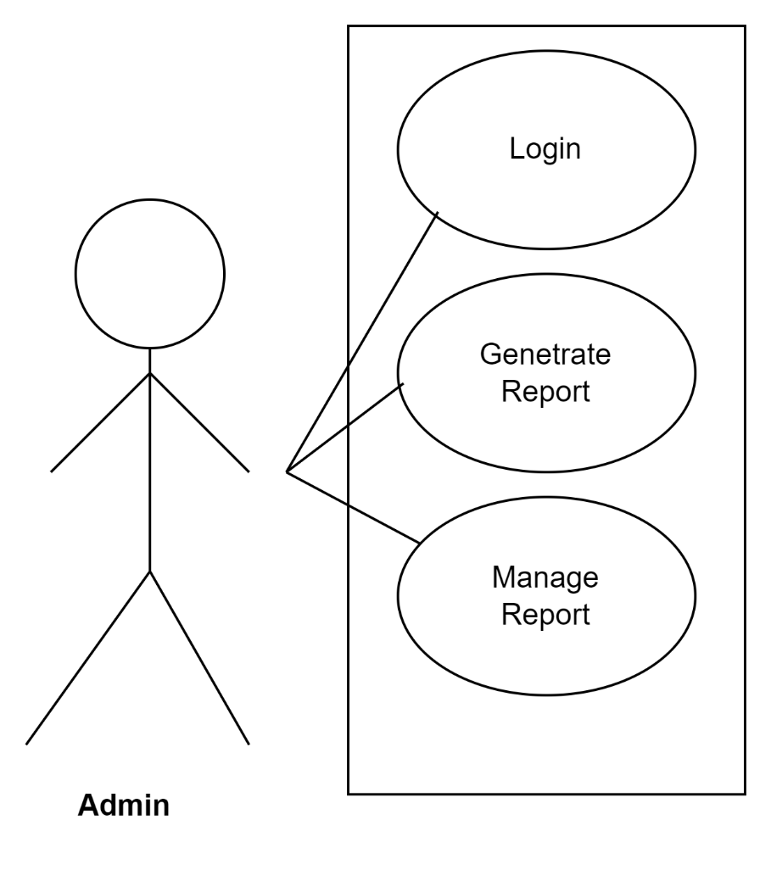

Fig. Use-Case Diagram for Admin.

## 5.2 Customer:

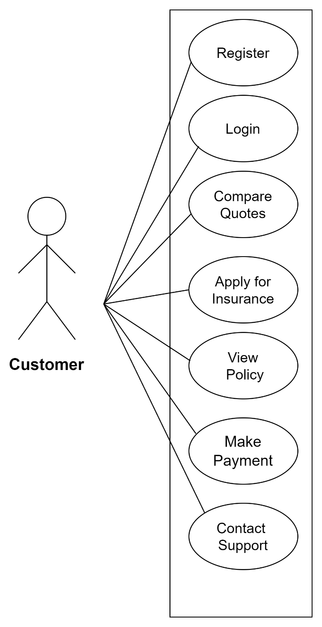

Fig. Use-Case Diagram for Customer

**5.3 Policy Provider Company:**

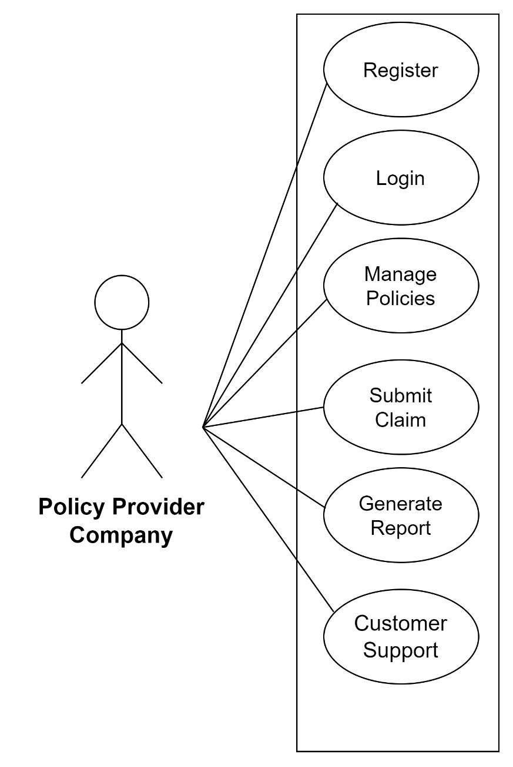

Fig. Use-Case Diagram for Policy Provider Company

**6. Database Design:**

1. **login table**

|  |  |  |  |  |  |
| --- | --- | --- | --- | --- | --- |
| **Login** | | | | | |
| **Field** | **Type** | **Null** | **Key** | **Default** | **Description** |
| Login_id | int | No | PK | Null | AI |
| email | varchar(50) | No |  | Null |  |
| password | varchar(50) | No |  | Null |  |
| user_type | int | YES |  |  |  |

**2] Vehicle Info table**

|  |  |  |  |  |  |
| --- | --- | --- | --- | --- | --- |
| **Vehicle_Info** | | | | | |
| **Field** | **Type** | **Null** | **Key** | **Default** | **Description** |
| v_id | Int | No | PK | Null |  |
| vehicle_no | varchar(20) | No | UNI | Null |  |
| brand_name | varcha(20) | No |  | Null |  |
| model | varchar(255) | No |  | Null |  |
| chassis_no | Int | No | UNI | Null |  |
| year_of_manufacture | Date | No |  |  |  |

**3] Customer table**

|  |  |  |  |  |  |
| --- | --- | --- | --- | --- | --- |
| **Customer** | | | | | |
| **Field** | **Type** | **Null** | **Key** | **Default** | **Description** |
| cust_id | int | No | PK | Null | AI |
| login_id | int | Yes | FK | Null |  |
| name | varchar(50) | No |  | Null |  |
| password | varchar(50) | No |  | Null |  |
| contact_no | varchar(10) | No |  | Null |  |
| email | varchar(50) | No | UNI | Null |  |
| bdate | date | No |  | Null |  |
| vehicle_id | int | Yes | FK | Null |  |

**4] Company table**

|  |  |  |  |  |  |
| --- | --- | --- | --- | --- | --- |
| **Company** | | | | | |
| **Field** | **Type** | **Null** | **Key** | **Default** | **Description** |
| comp_id | int | NO | PRI | Null |  |
| login_id | int | Yes | FK | Null |  |
| company_name | varchar(25) | NO |  | Null |  |
| email | varchar(50) | NO |  | Null |  |
| password | varchar(20) | NO |  | Null |  |
| address | varchar(50) | NO |  | Null |  |
| contact_no | Varchar(12) | NO | UNI | Null |  |
| license_no | Varchar(50) | NO | UNI | Null |  |

**5] Policy plan table**

|  |  |  |  |  |  |
| --- | --- | --- | --- | --- | --- |
| **Plan** | | | | | |
| **Field** | **Type** | **Null** | **Key** | **Default** | **Description** |
| plan_id | INT | No | Pk | Null | AI |
| plan_name | VARCHAR(50) | No |  | Null |  |
| description | VARCHAR(255) | No |  | Null |  |
| comp_id | INT | Yes | FK | Null |  |
| duration | INT | Yes | 1 | Null |  |
| coverage_type | VARCHAR(50) | No |  | Null |  |
| premium_amount | DECIMAL(10,2) | No |  | Null |  |

**6] Policy details table**

|  |  |  |  |  |  |
| --- | --- | --- | --- | --- | --- |
| **Policy_details** | | | | | |
| **Field** | **Type** | **Null** | **Key** | **Default** | **Description** |
| policy_id | int | NO | PK | Null | AI |
| plan_id | int | YES | FK | Null |  |
| cust_id | int | YES | FK | Null |  |

**7] Payment table**

|  |  |  |  |  |  |
| --- | --- | --- | --- | --- | --- |
| **Payment** | | | | | |
| **Field** | **Type** | **Null** | **Key** | **Default** | **Description** |
| payment_id | int | NO | PK | Null |  |
| cust_id | int | YES | FK | Null |  |
| comp_id | int | YES | FK | Null |  |
| status | Varchar(5) | NO |  | Null |  |
| amount | decimal(10,2) | NO |  | Null |  |
| payment_date | date | NO |  | Null |  |

## ER-Diagram:

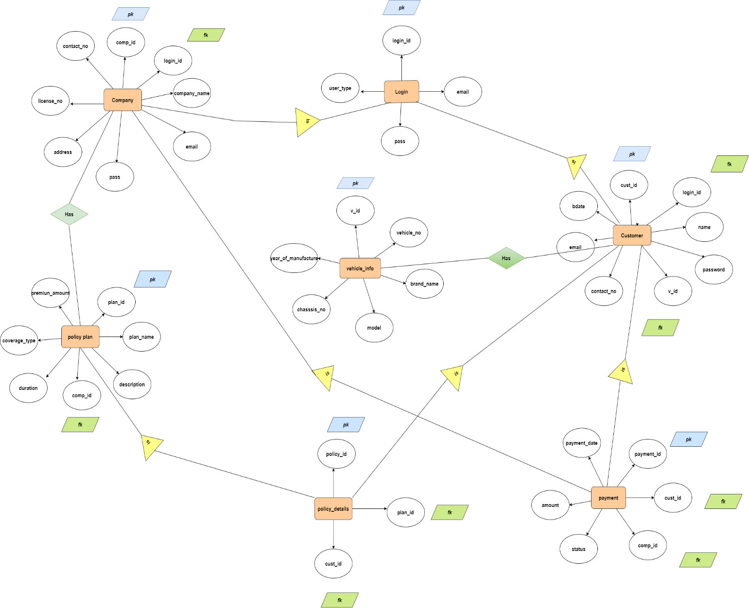

**E-R diagram shows database of Vehicle Insurance.**

**8. Architecture Diagram :**

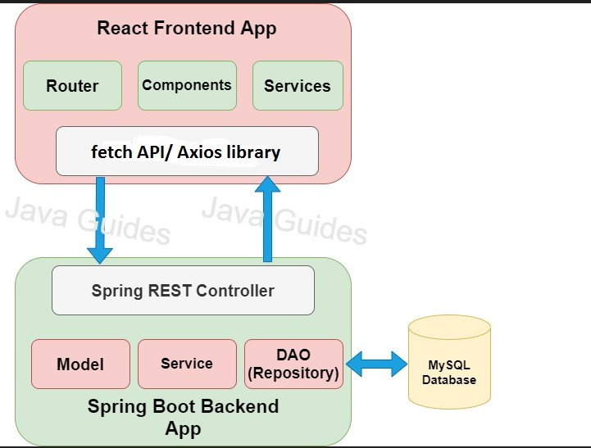

**9. Snapshots:**

**9.1 Home Page:**

Following snapshot shows the Home page for Compare Vehicle Insurance before Login.

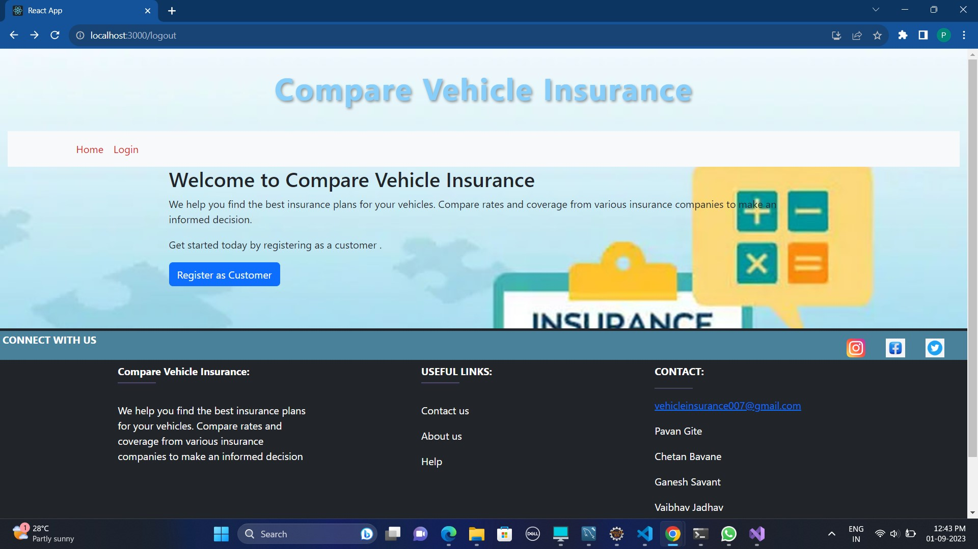

This page contains following controls

* Home
* About
* Contact
* Login
* Admin Registration
* Customer Registration
* Policy Company Registration

**9.1.1 Login Page**

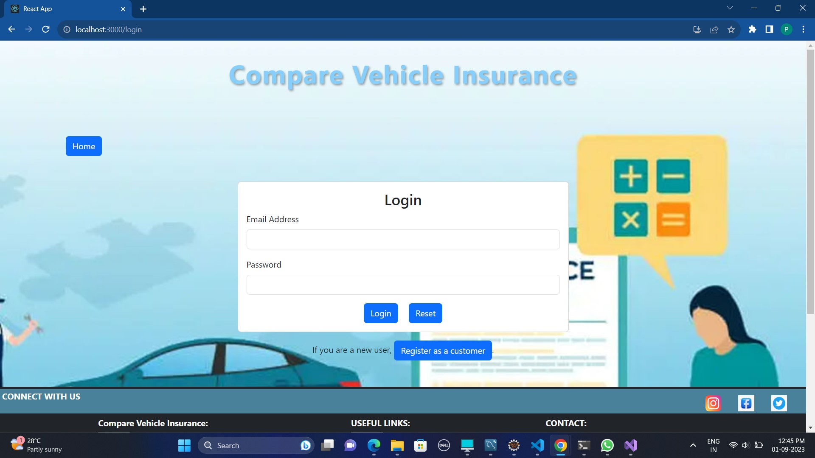

**9.2 Admin Login Page**

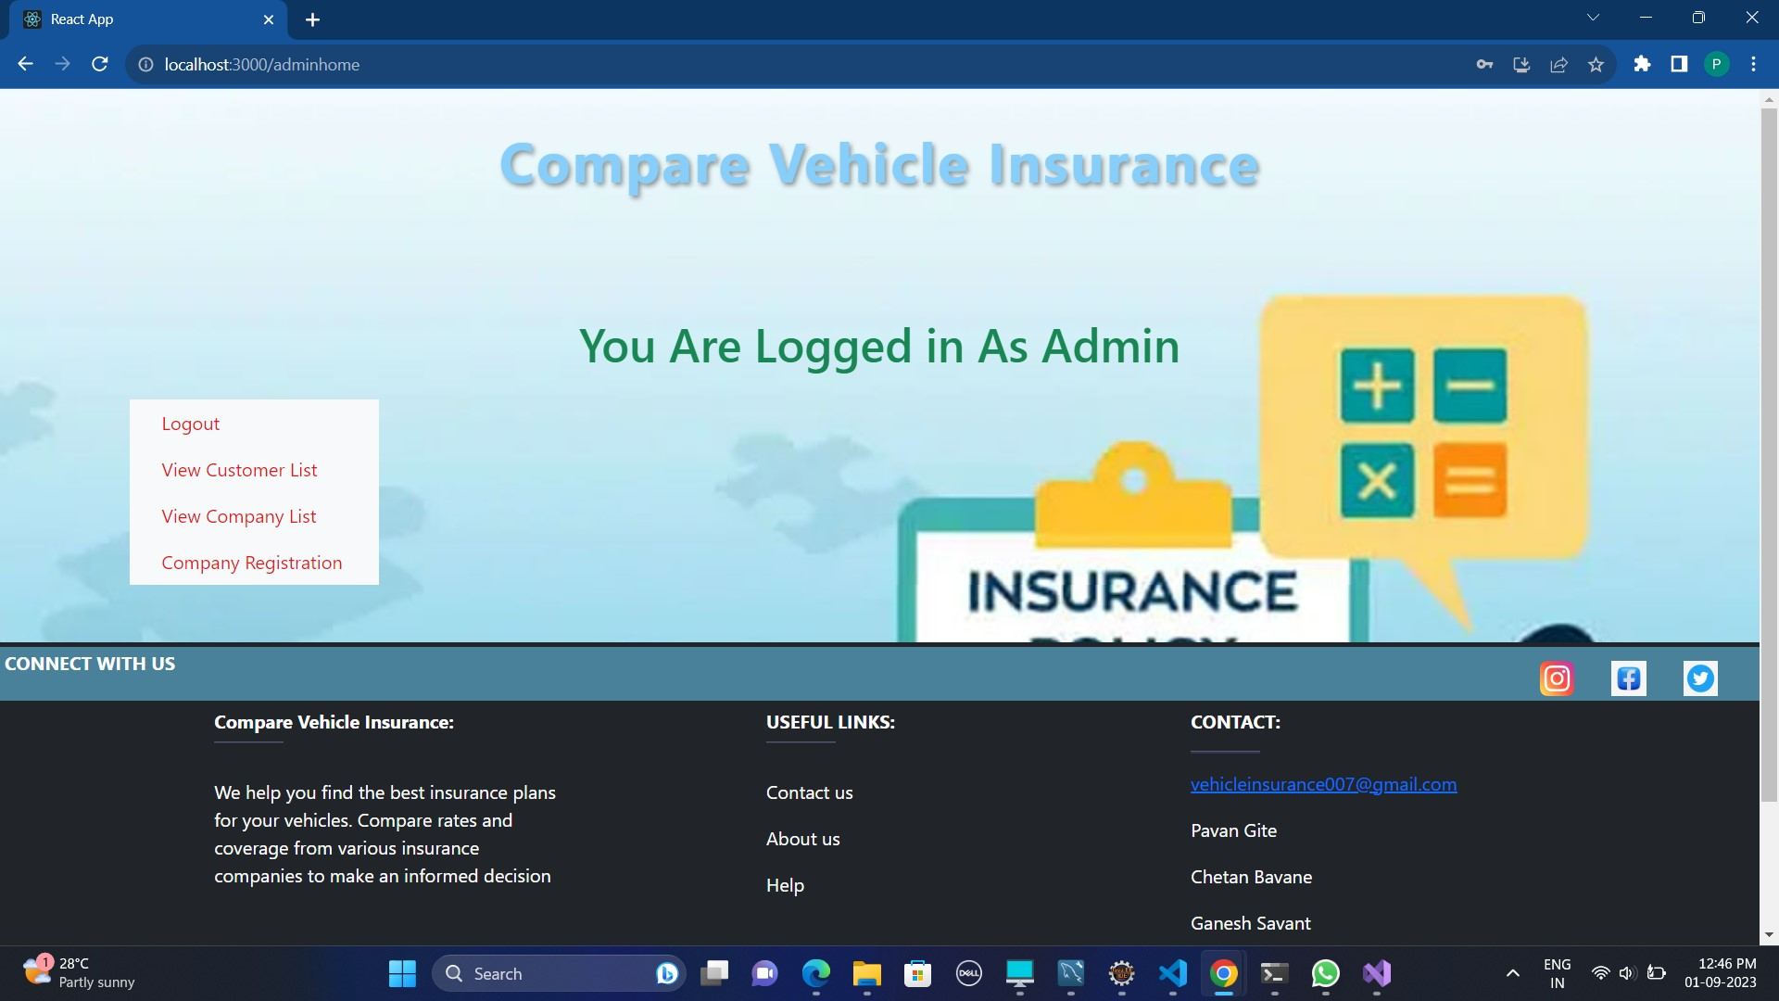

**9.2.1 Admin Policy Company View Page**

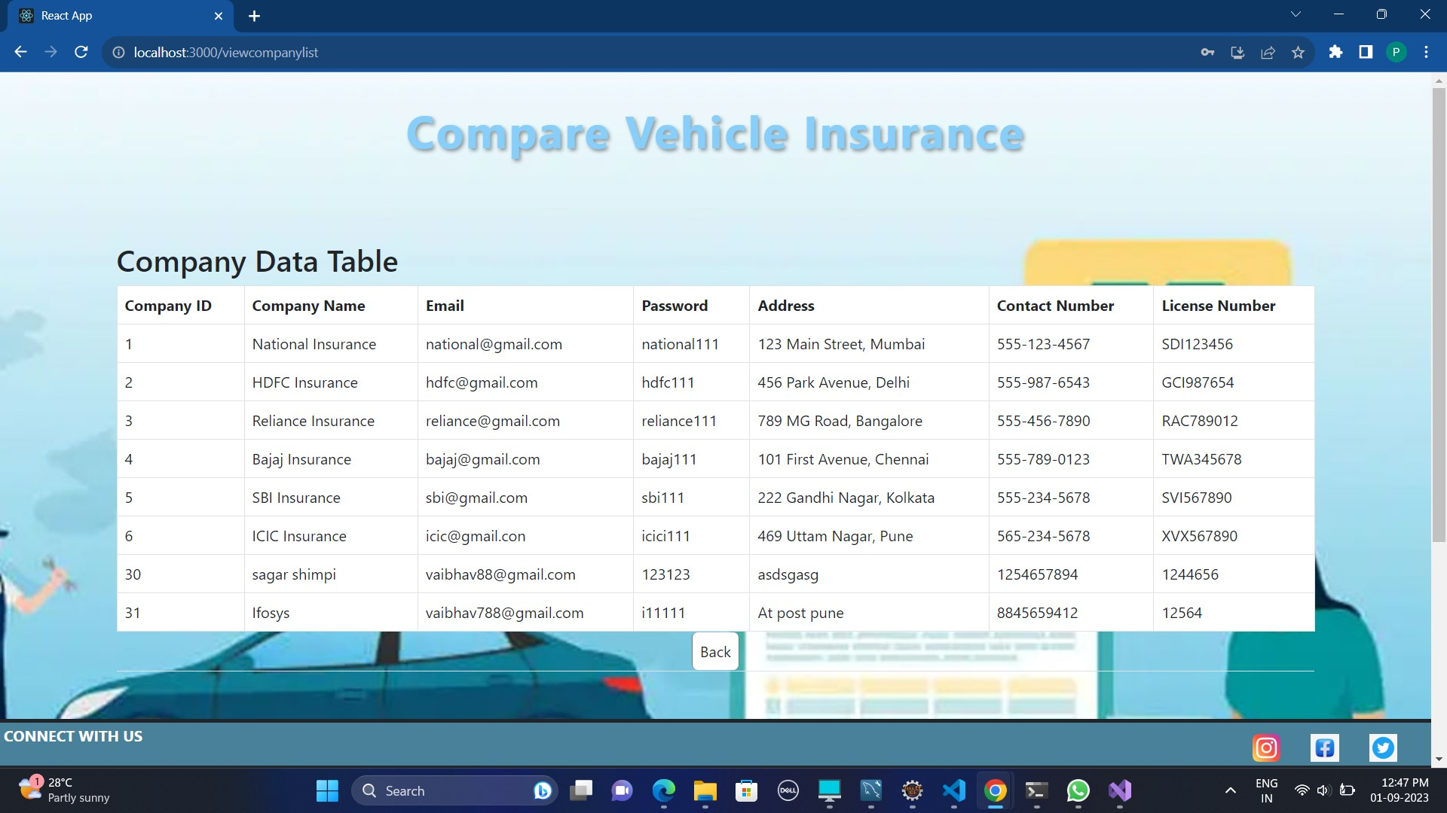

**9.2.2 Admin Customer View Page**

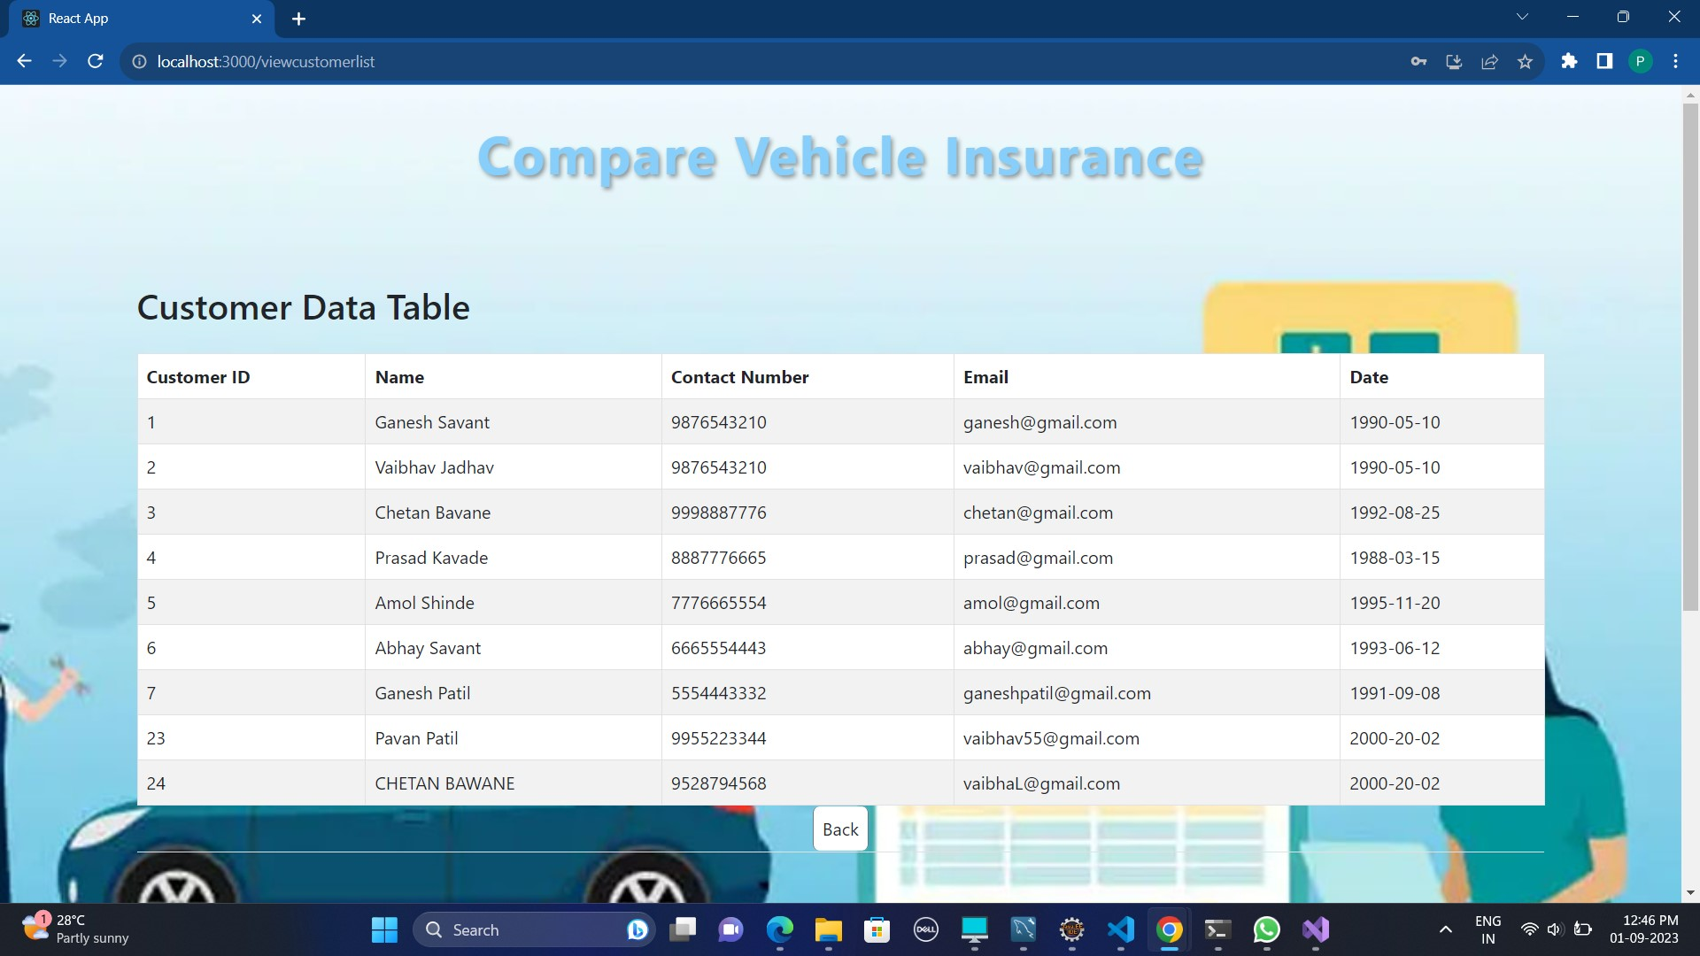

**9.3 Customer Registration Page**

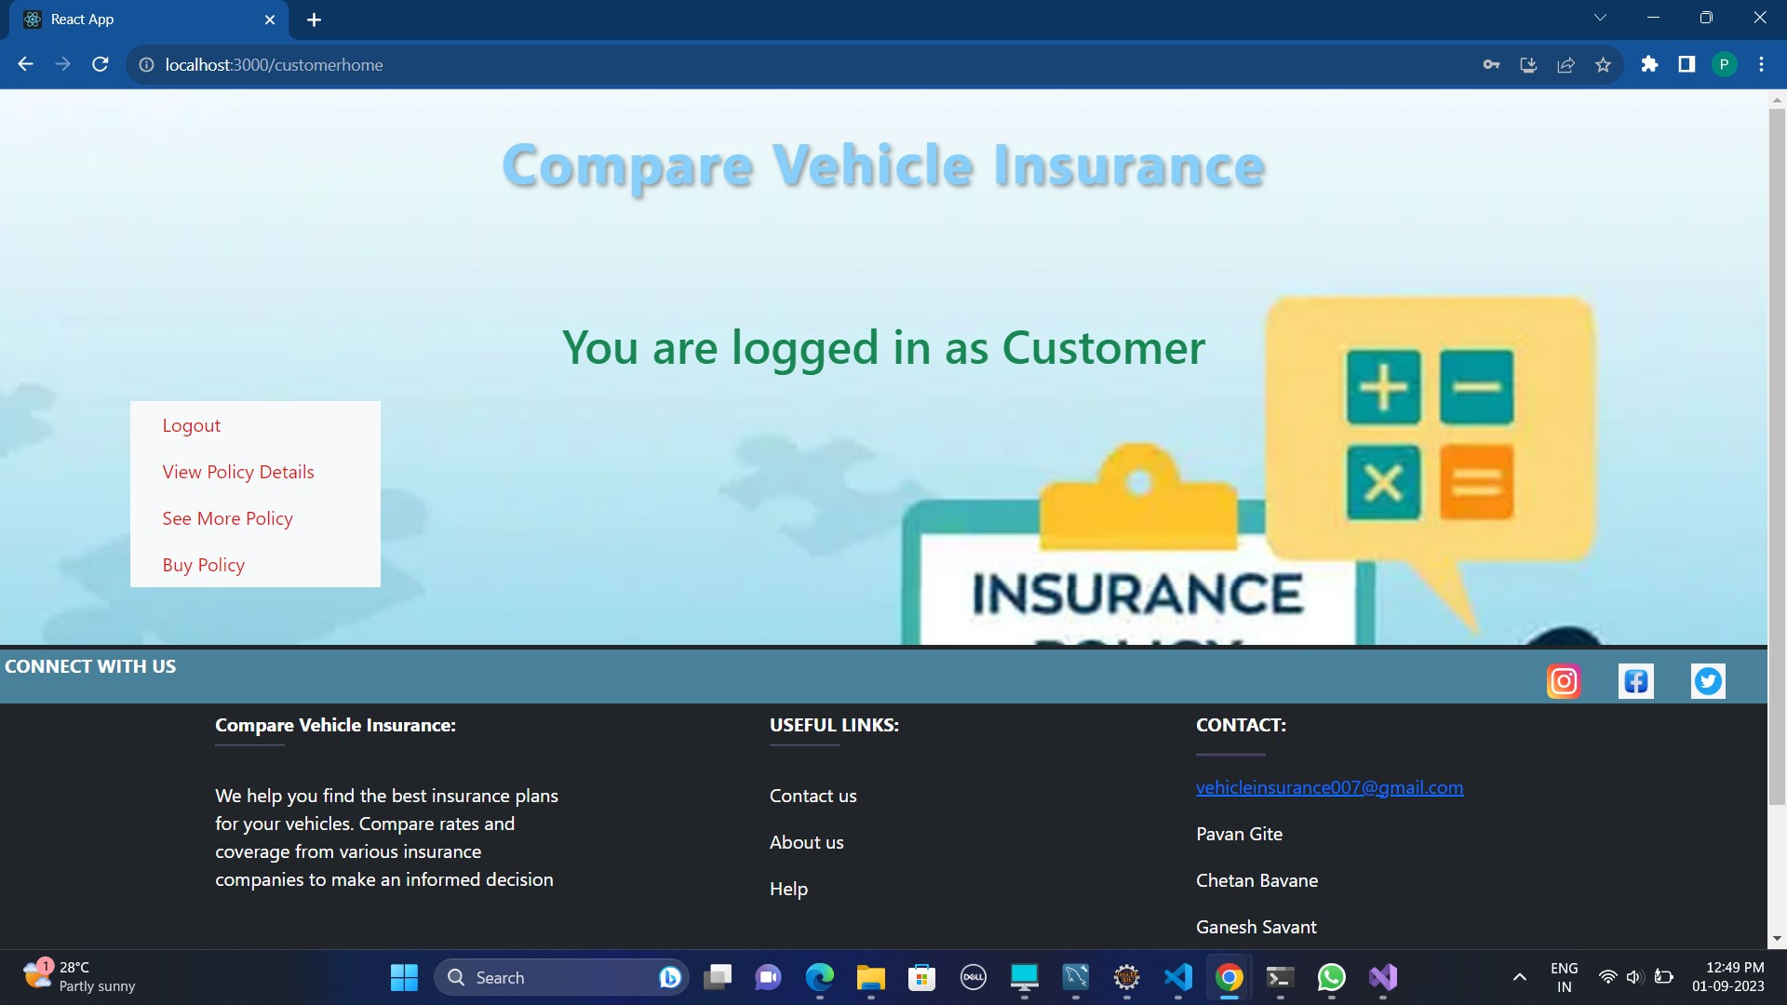

**9.3.1 Customer Login Page**



**9.3.2 Customer Policy View Page**

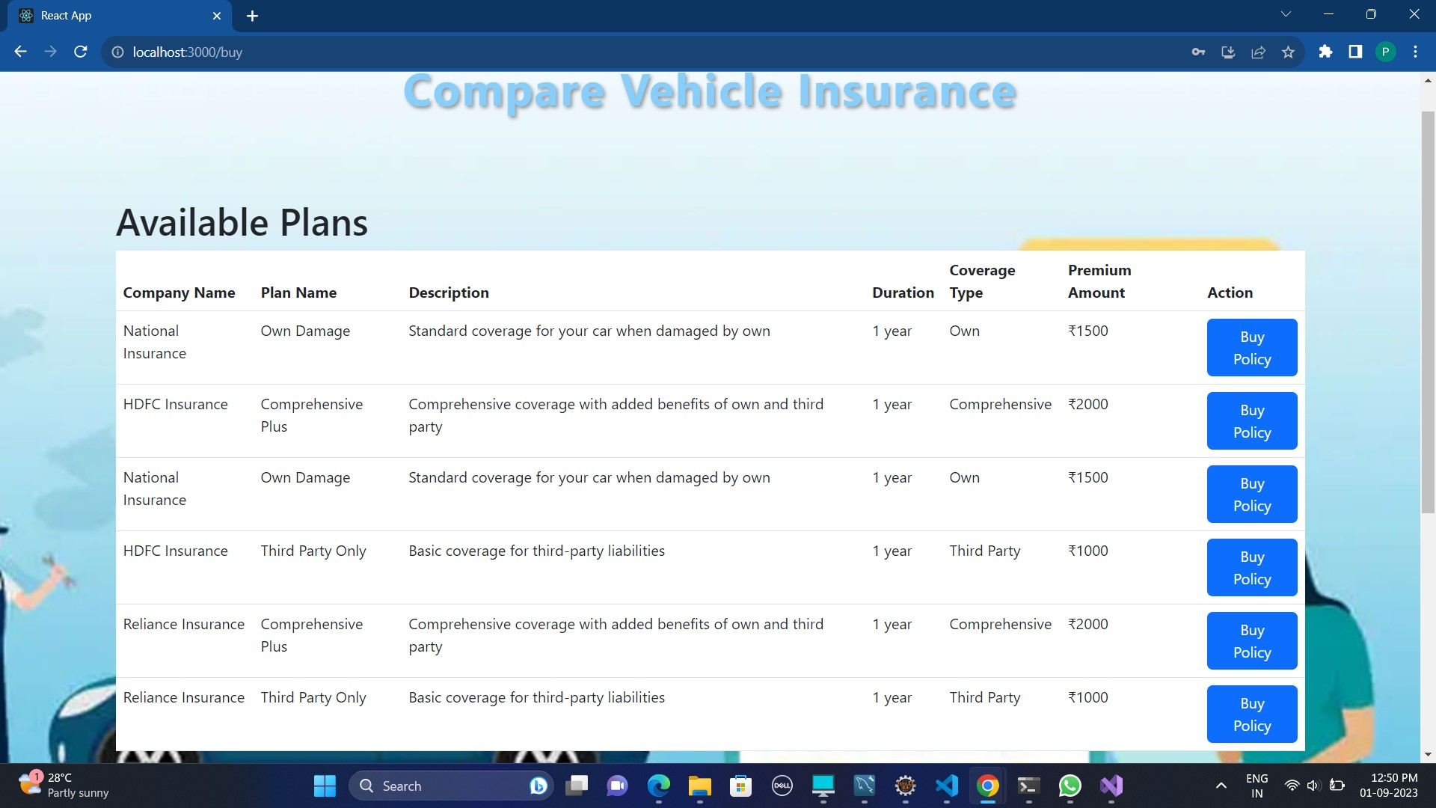

**9.3.3 Customer Payment Page**

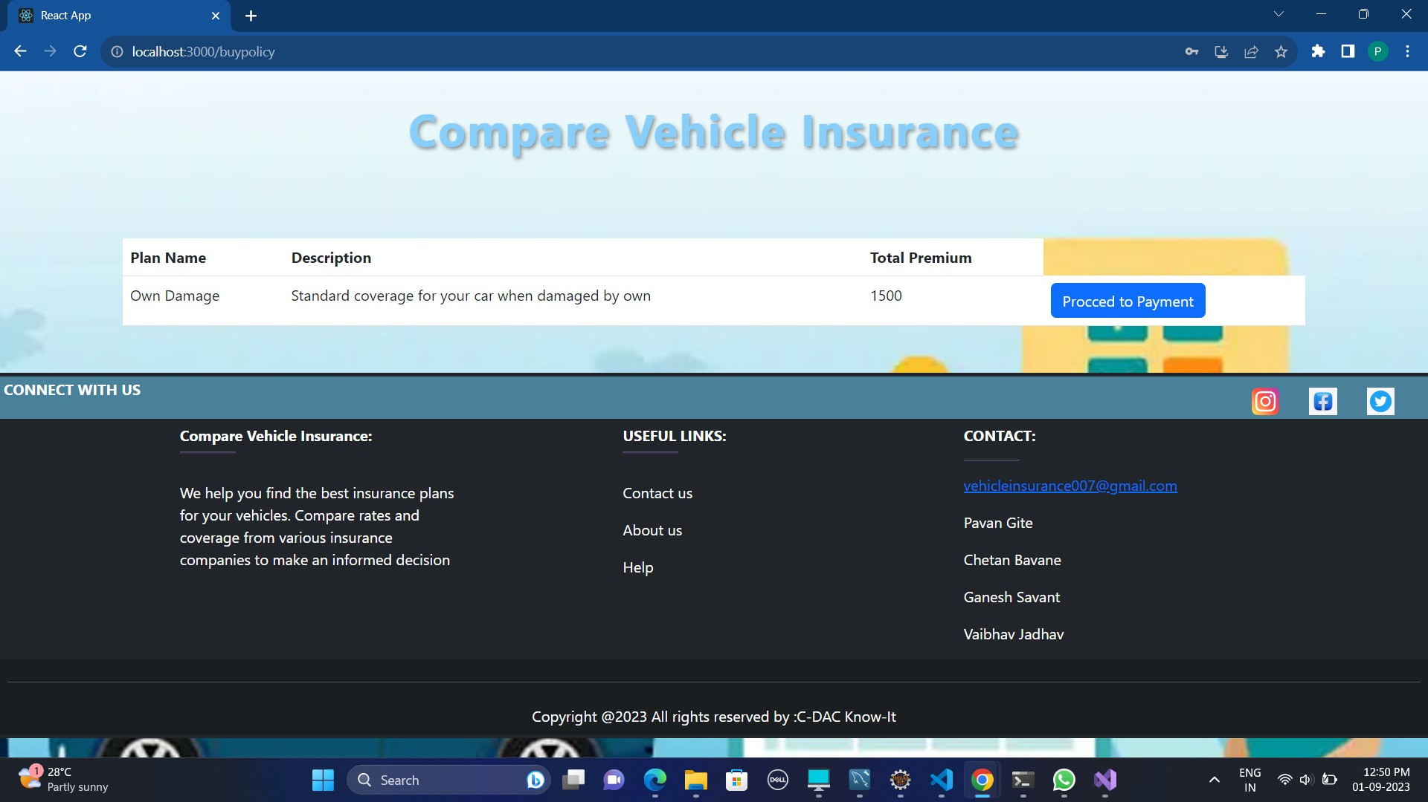

**9.4 Policy Company Registration Page**

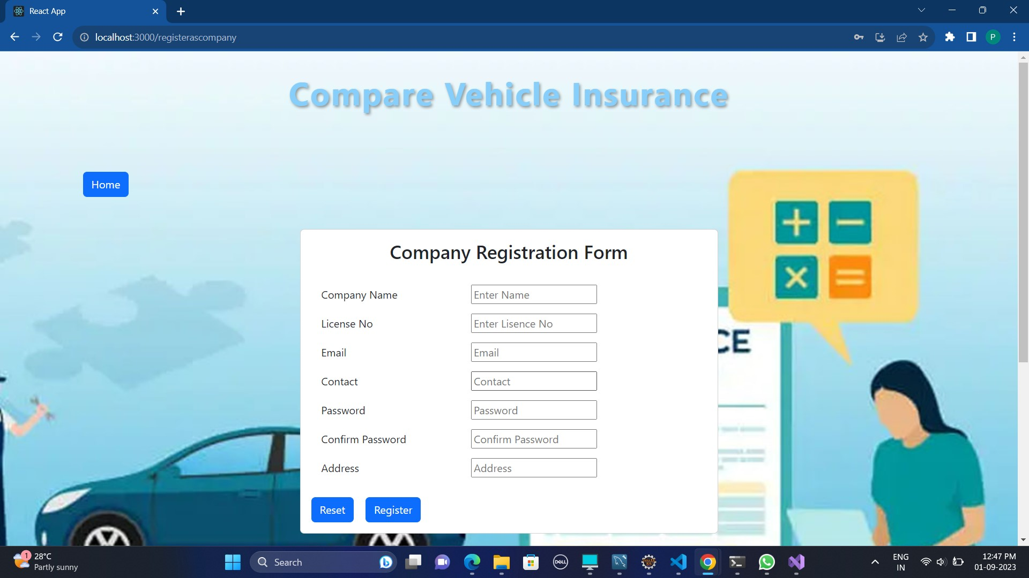

**9.4.1 Company Login Page**

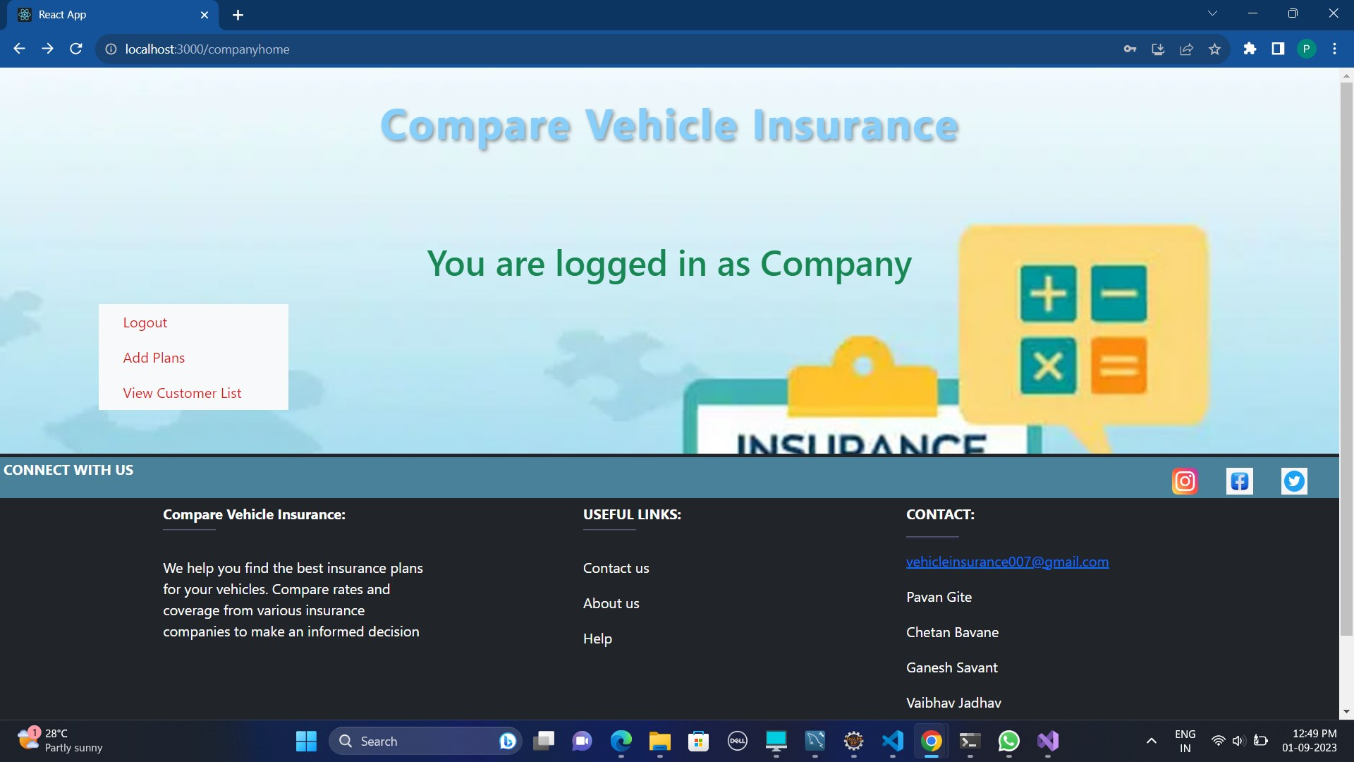

**10. CONCLUSION AND FUTURE SCOPE**

Comparing vehicle insurance is crucial to finding the right coverage at the right price. It involves assessing your needs, researching options, and making an informed decision.

In conclusion, the future of vehicle insurance is likely to be marked by increased personalization, technological innovation, and a focus on sustainability and security. Staying informed about these trends and embracing new technologies can help both insurers and policyholders make the most of the evolving landscape in the years to come.